whttps://www.figma.com/file/sRNXm1OmUZ3MdSecSksdDw/Complaint-Management-System?type=design&node-id=0-1&mode=design

https://www.figma.com/proto/uILFRNTZyDpCC3zAPP7SXk/CMSC-Prototype?page-id=0%3A1&type=design&node-id=11-160&viewport=-421%2C461%2C0.62&t=JhFWMv0VOM83ev9A-1&scaling=scale-down&starting-point-node-id=1%3A40

https://github.com/Roxhitttt/NMC-final-yr-project

https://www.figma.com/proto/uILFRNTZyDpCC3zAPP7SXk/CMSC-Prototype?page-id=0%3A1&type=design&node-id=11-160&viewport=-421%2C461%2C0.62&t=JhFWMv0VOM83ev9A-1&scaling=scale-down&starting-point-node-id=1%3A40

Gmail (Request for meeting mail to nmc)- https://mail.google.com/mail/u/0/?ogbl#search/t/FMfcgzGtxSpBdDskrkJPgprGMVLtwvCT

Gmial (Approval letter from nmc) - https://mail.google.com/mail/u/0/?ogbl#starred/FMfcgzGtwqMCQRvsxtLlHtNzcPClxsnB

Gmail (Figma group invite ) - https://mail.google.com/mail/u/0/#starred/FMfcgzGtwzspZwlFsqvhxhSGXTQWKPsw

_______________________________________________________________________________________________________________________________________________________

Project Review-2

Points of Review:

1.Problem Defination

2.Motivation

3.Objective

4.Scope

5.Process Description

6.Software-Hardware Requirements

7.Stregnth

8.Limitations

9.Referencess

_________________________________________________________________________________________

Project Review-3

Points of Review:

* Feasibility- <https://www.youtube.com/watch?v=JNLRXczA9Y0&list=PLxCzCOWd7aiEed7SKZBnC6ypFDWYLRvB2&index=144>

Feasibility is that is our project will execute or not – check all the things before it.

2. Requirement Analysis-

_________________________________________________________________________________________

3. System Architecture

_________________________________________________________________________________________

4. Class Diagram - <https://youtu.be/HuL9EMx8NQo?si=_vGWFI5UHsuZMQ-->

OOPS concept is used in class Diagram :

Represent as a class

Attributes and Functions or Methods

Visibility –

1. + (Public)
2. – (Private)
3. # (protected)

Relationship –

1. Association = simple line : __________________________
2. Aggregation ( has a relationship ) = diamond and line : <>-----------------------------
3. Composition = <diamond filled >-------------------------------

Inheritance - Arrow is given >

Multiplicity –

0 – Zero

1- One

* - Many

1 – one customer can have ( 0 …* ) zero or many

1 – one customer can have ( 0 …1) zero or many

1 – one Bank can have ( * ) many branches

1 – one Branch can have ( 0 …*) zero or many

( 0 …* ) zero ya fhir many

( 1 …* ) one ya fhir many

( 0 …1 ) zero ya fhir one

Reliazation –

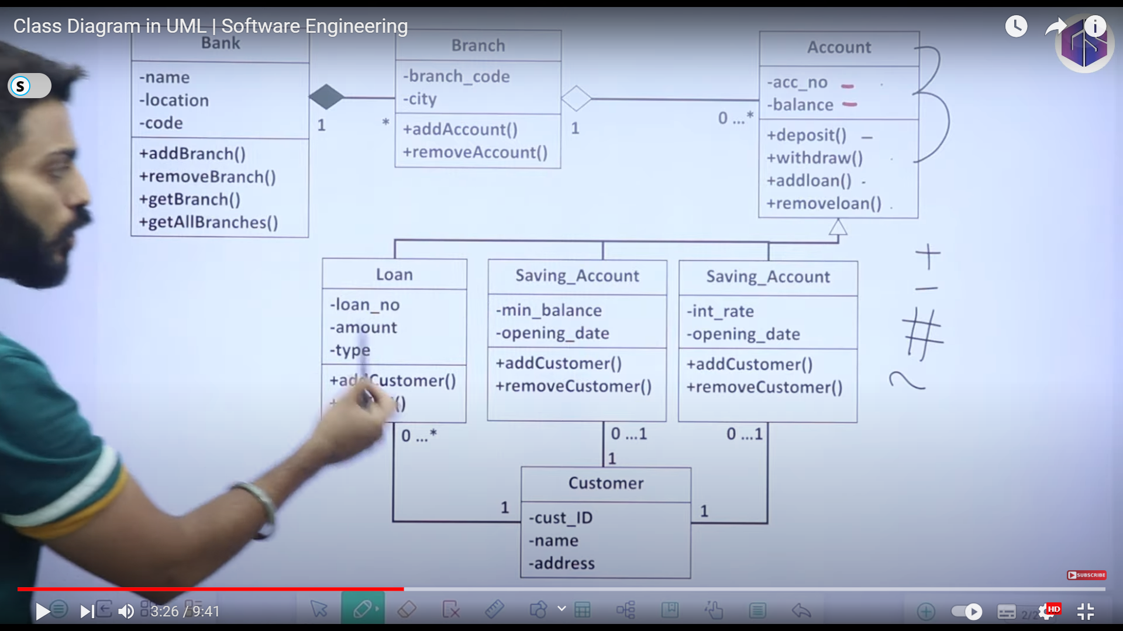

_________________________________________________________________________________________

1. Use Case Diagram- <https://youtu.be/Hj6Lkoi_VoM?si=NttZx-NutdPSEWOF>

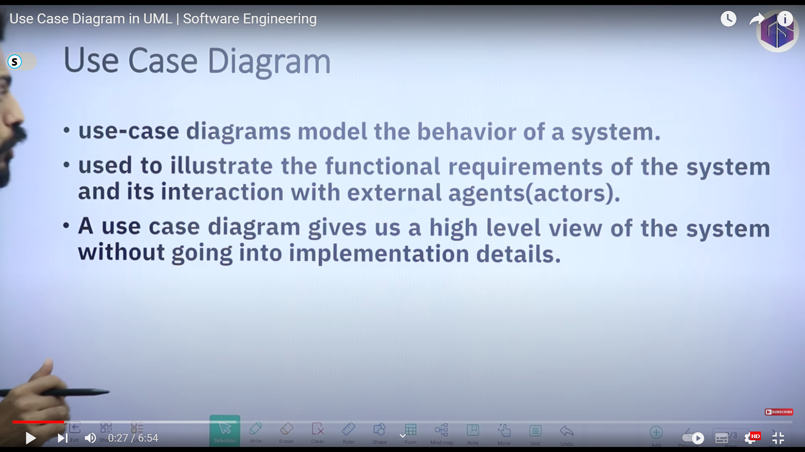

Extend Function ; -------->

Include Function --------->

Connector : Direct line ________________

System Boundary :

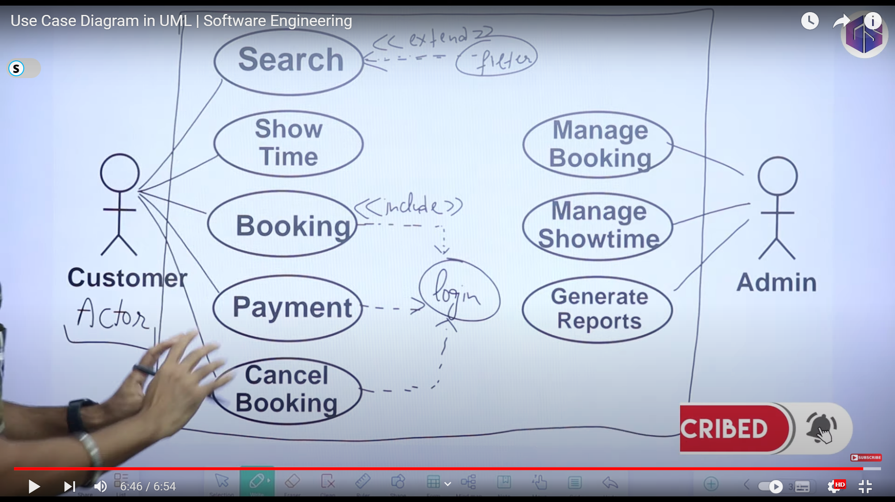

Connector

System Boundary

_________________________________________________________________________________________

1. Object Diagram - <https://www.youtube.com/watch?v=HacpzGKF5cU>

Object diagram : Taking Photo, Taking Screenshot : Who’s : inside system’s Instances, Objects, Relationships

Object diagram represents instances/objects and their relationships in the system.

* Object diagram is a snapshot of instances/objects and their relationships.
* Object diagram provides information about system functionality and interaction.

Snapshot of the instances of the objects of your system and their relationships between the objects at a given time, at a particular instance.

Notations :

Relationships also consider like Class diagram

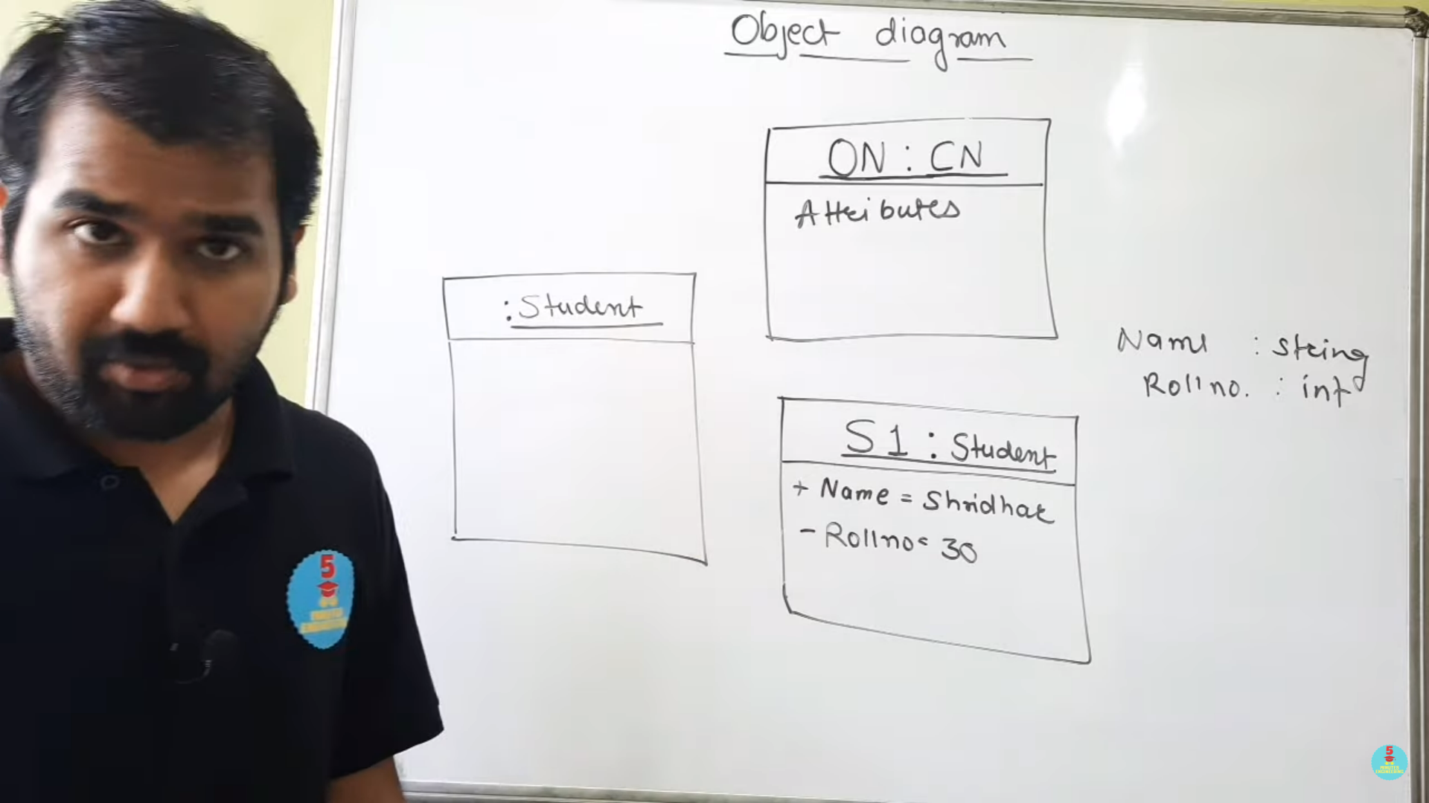

_________________________________________________________________________________________

Project Review -4

Points of Review:

1. Previously presented all topics

_________________________________________________________________________________________

2. DFD - https://youtu.be/KN-inGJG540?si=bmYrnNYYkFwyrEGR AND

<https://youtu.be/qtTWBs49BCA?si=OdaJphvFAq1vWQGu> AND

https://youtu.be/IQFfMb2T2PY?si=A7Ka_yI1f3QtV2tK

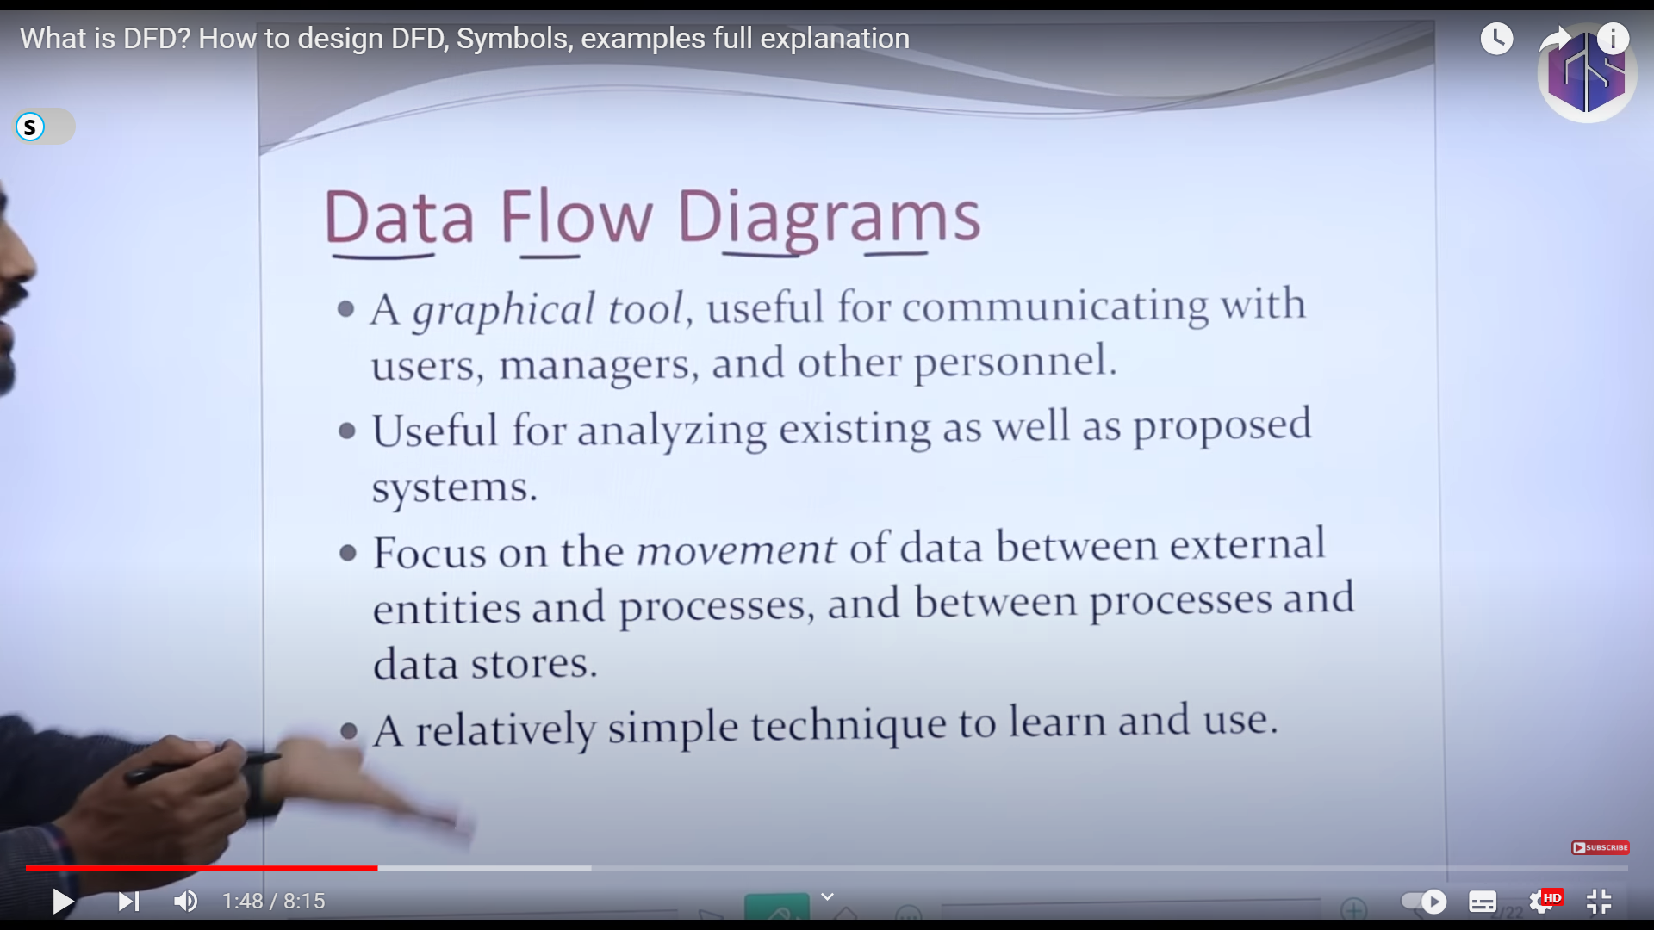

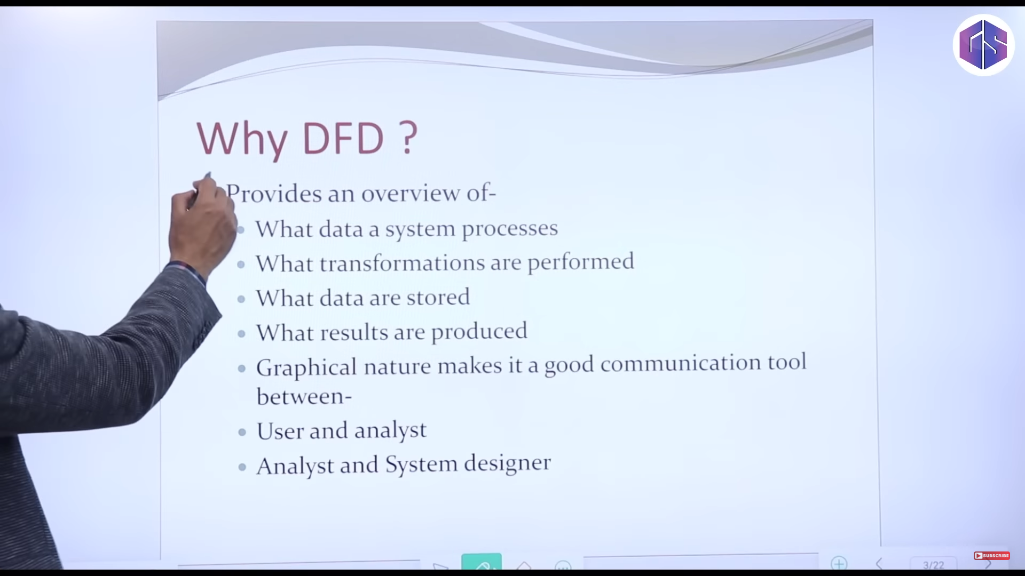 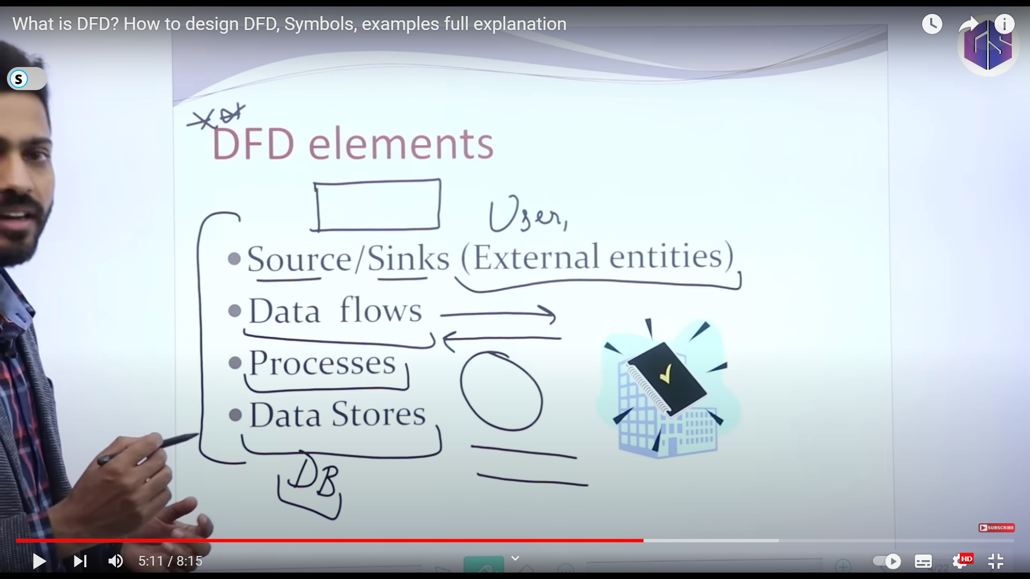

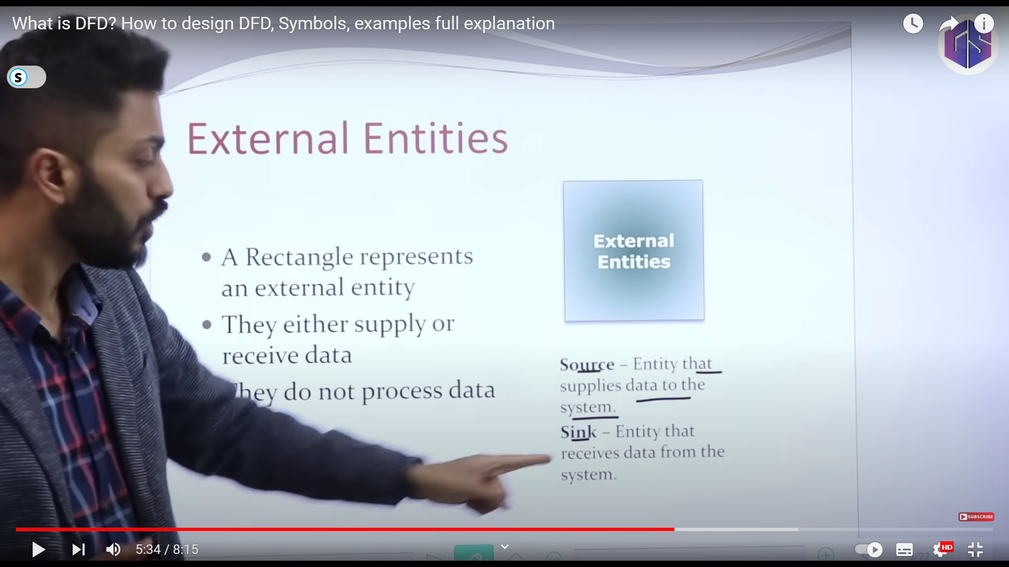

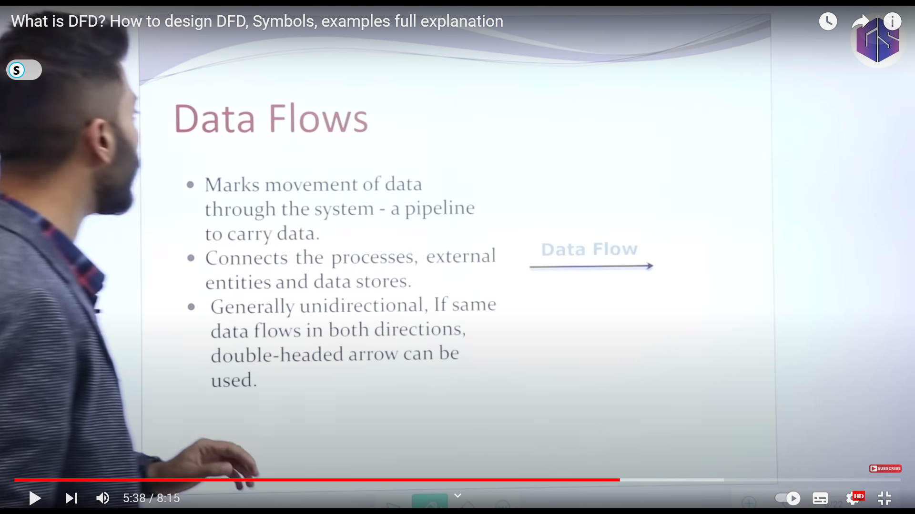

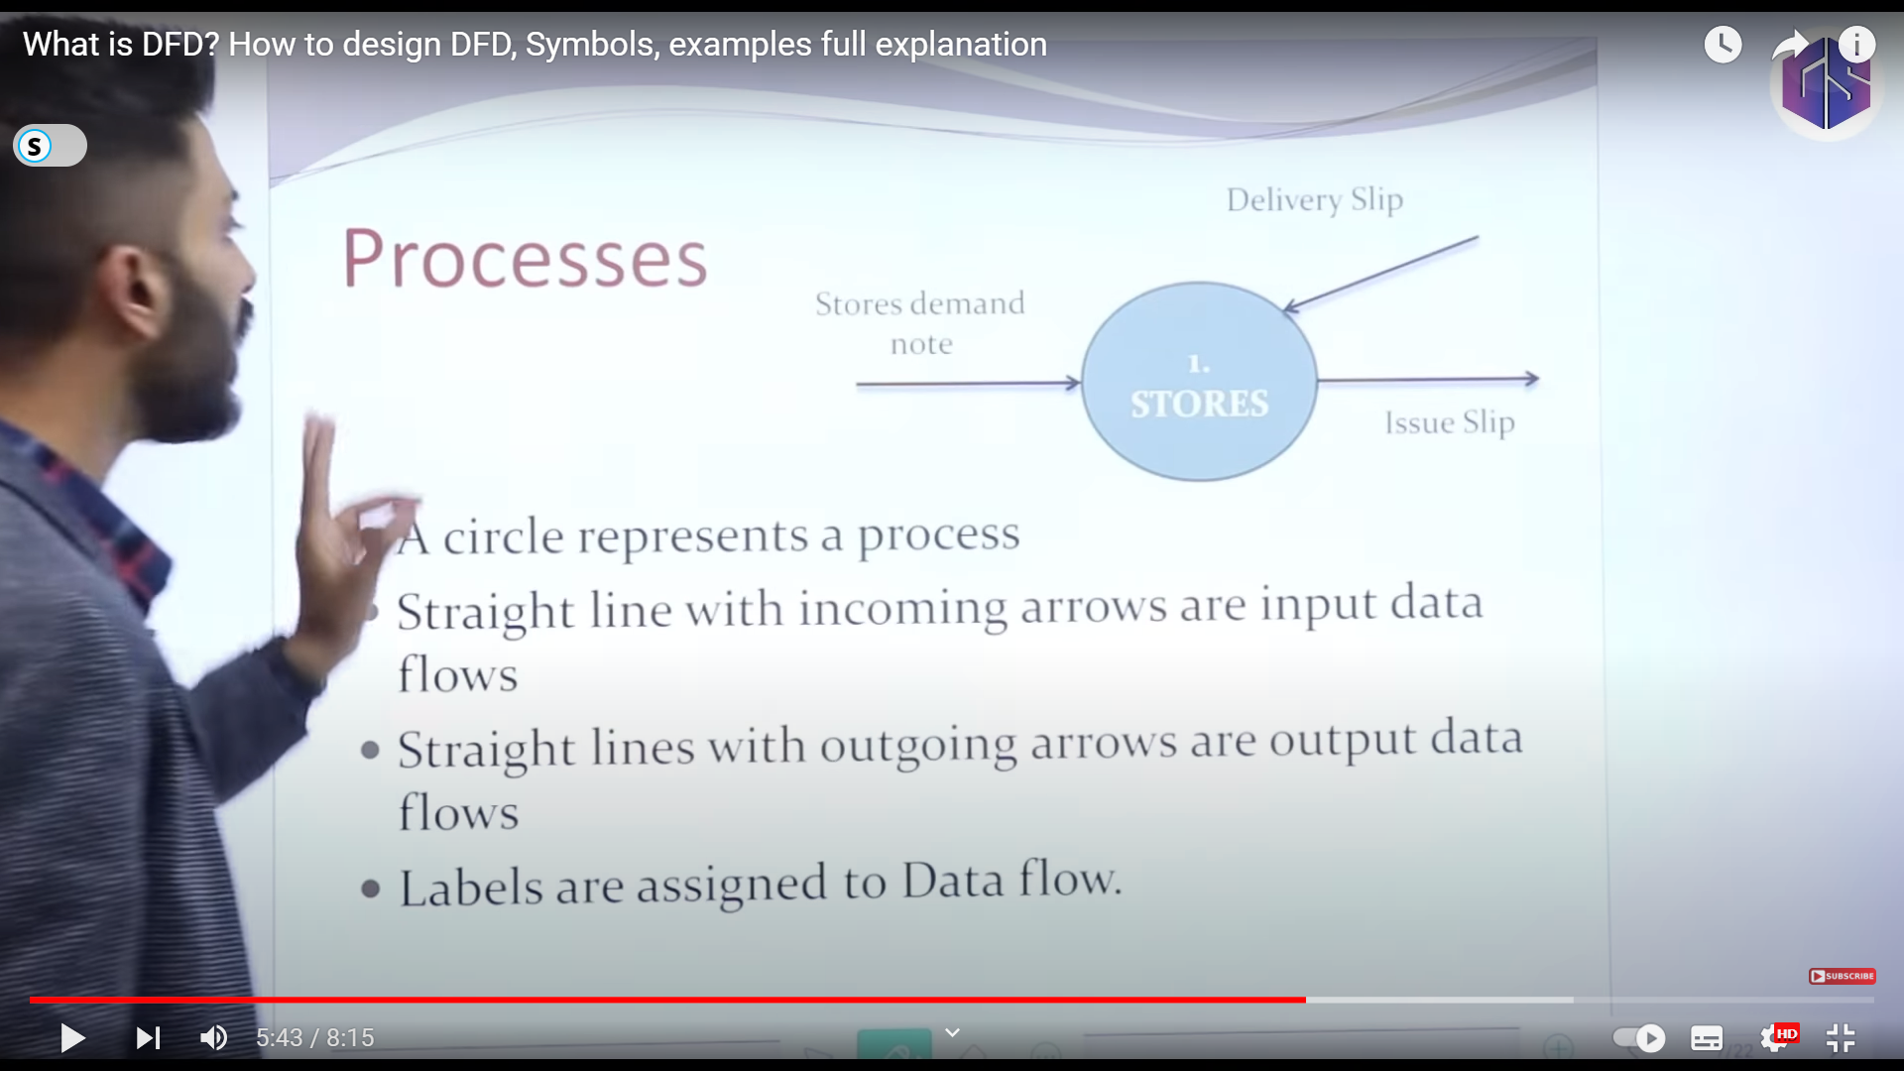

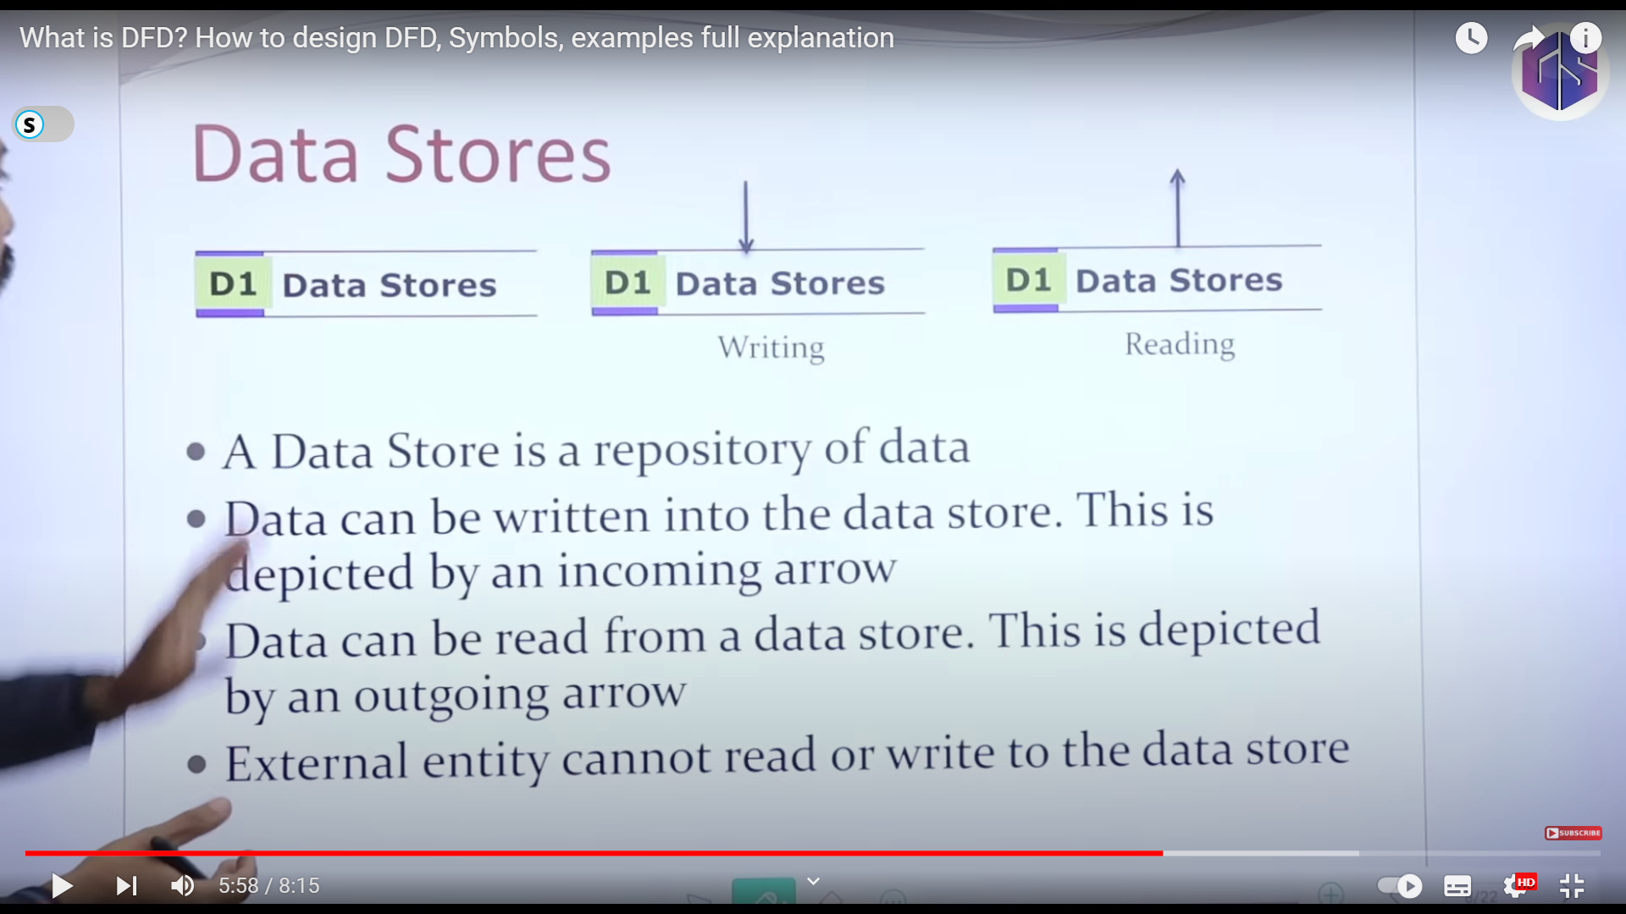

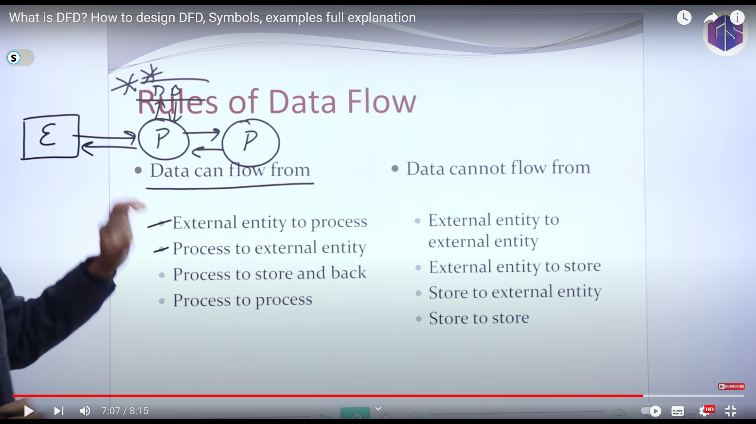

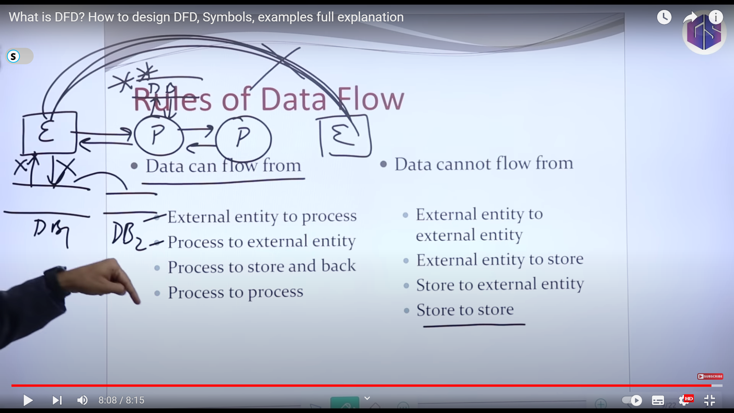

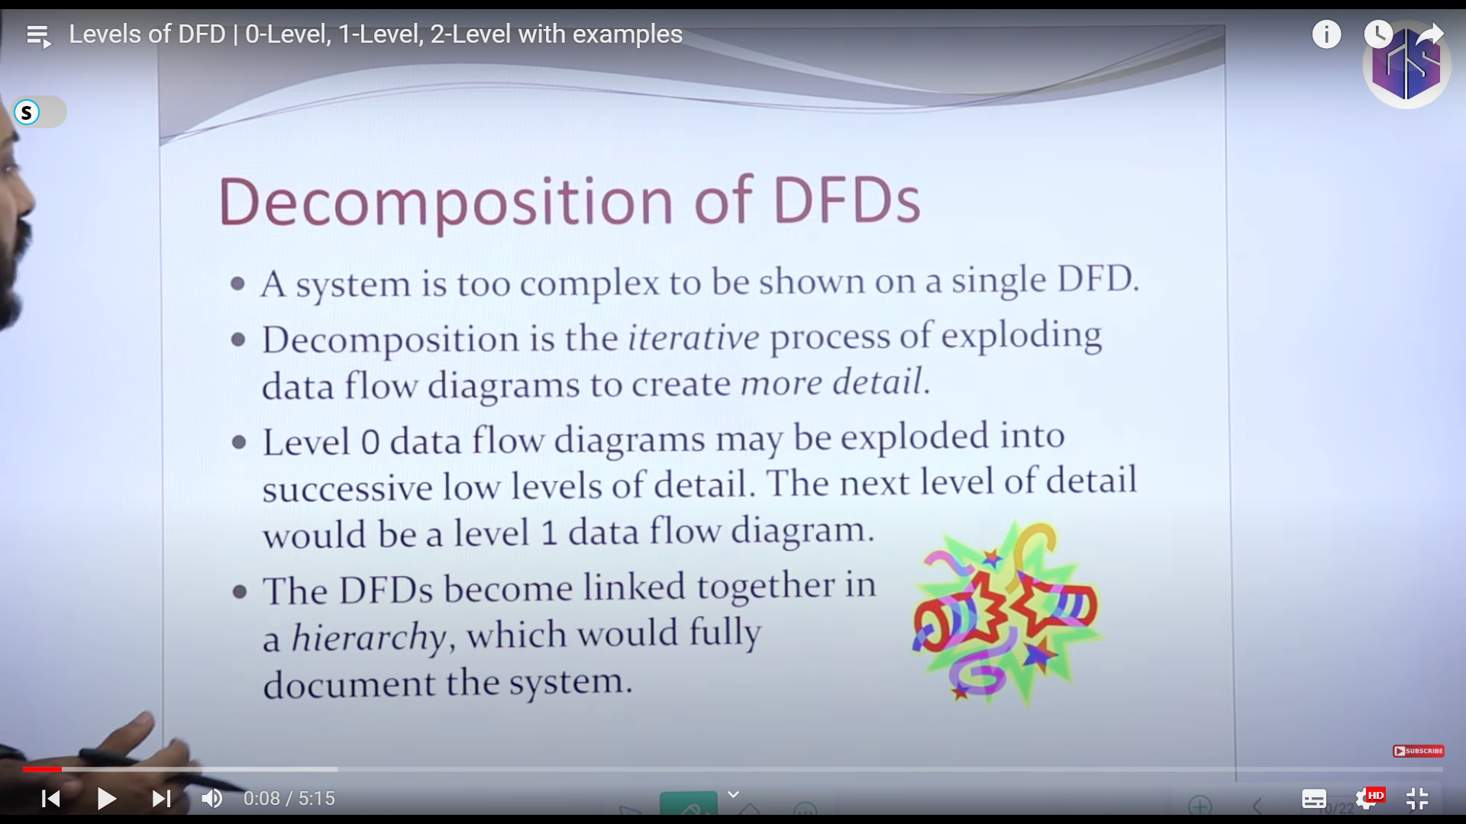

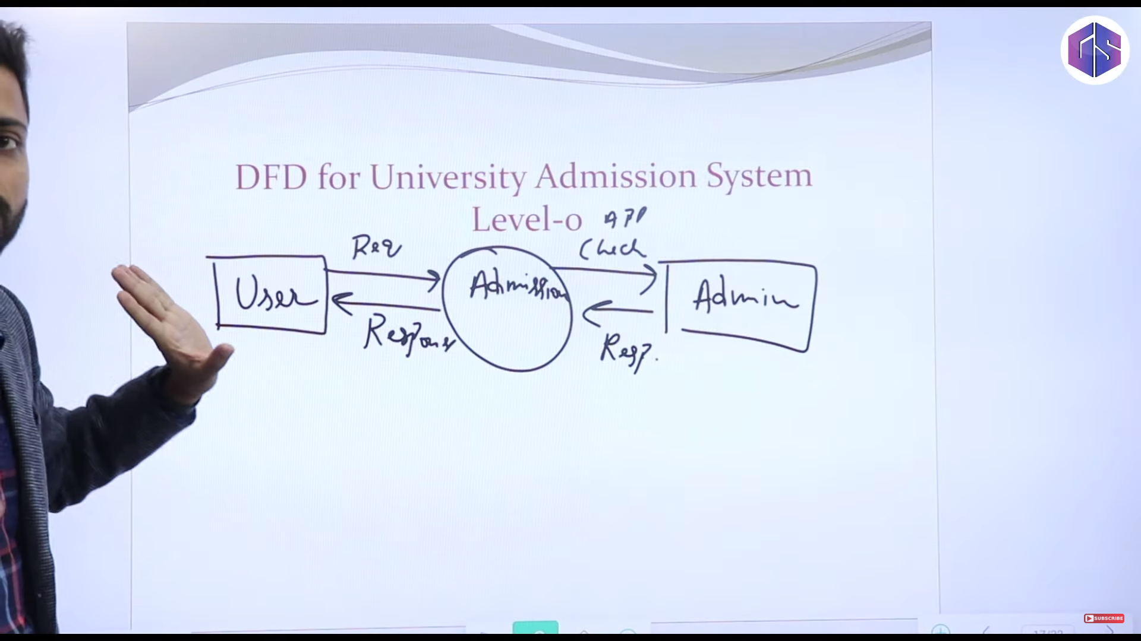

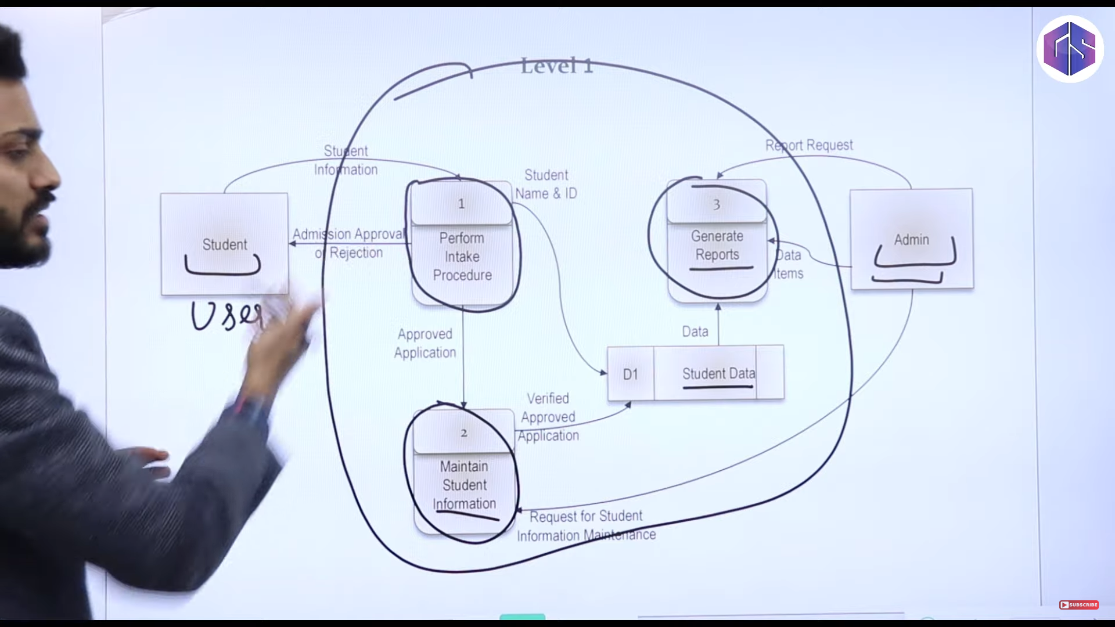

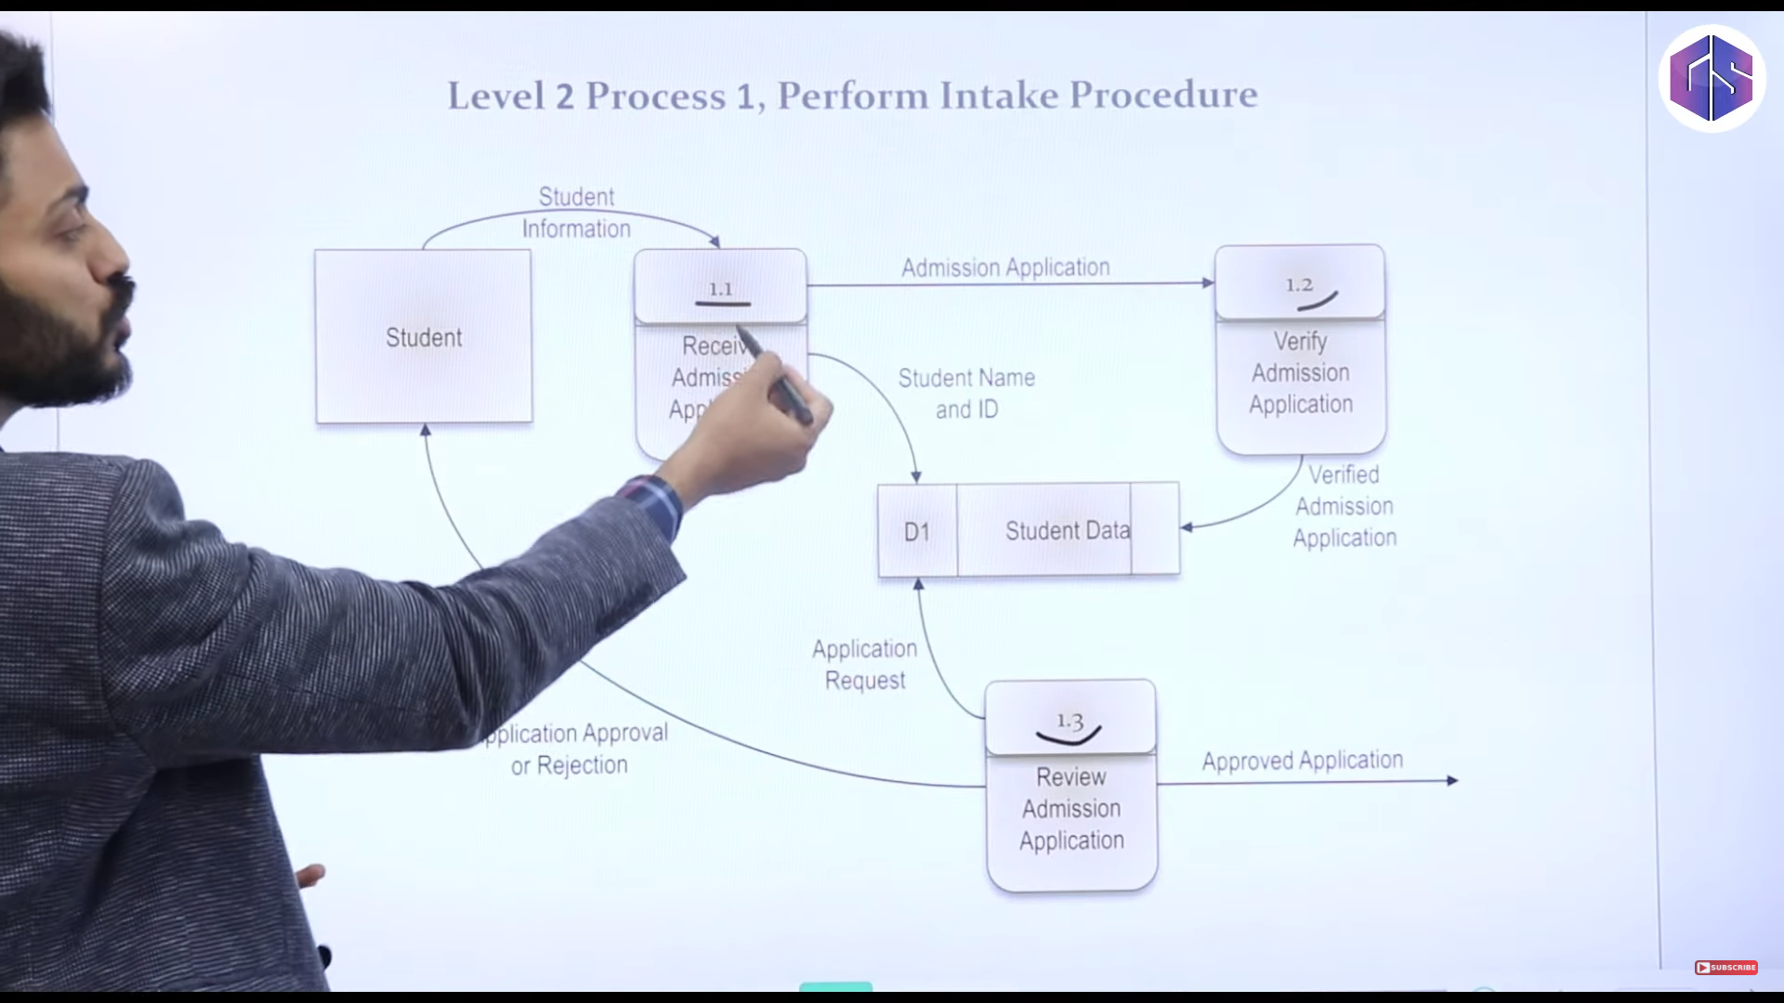

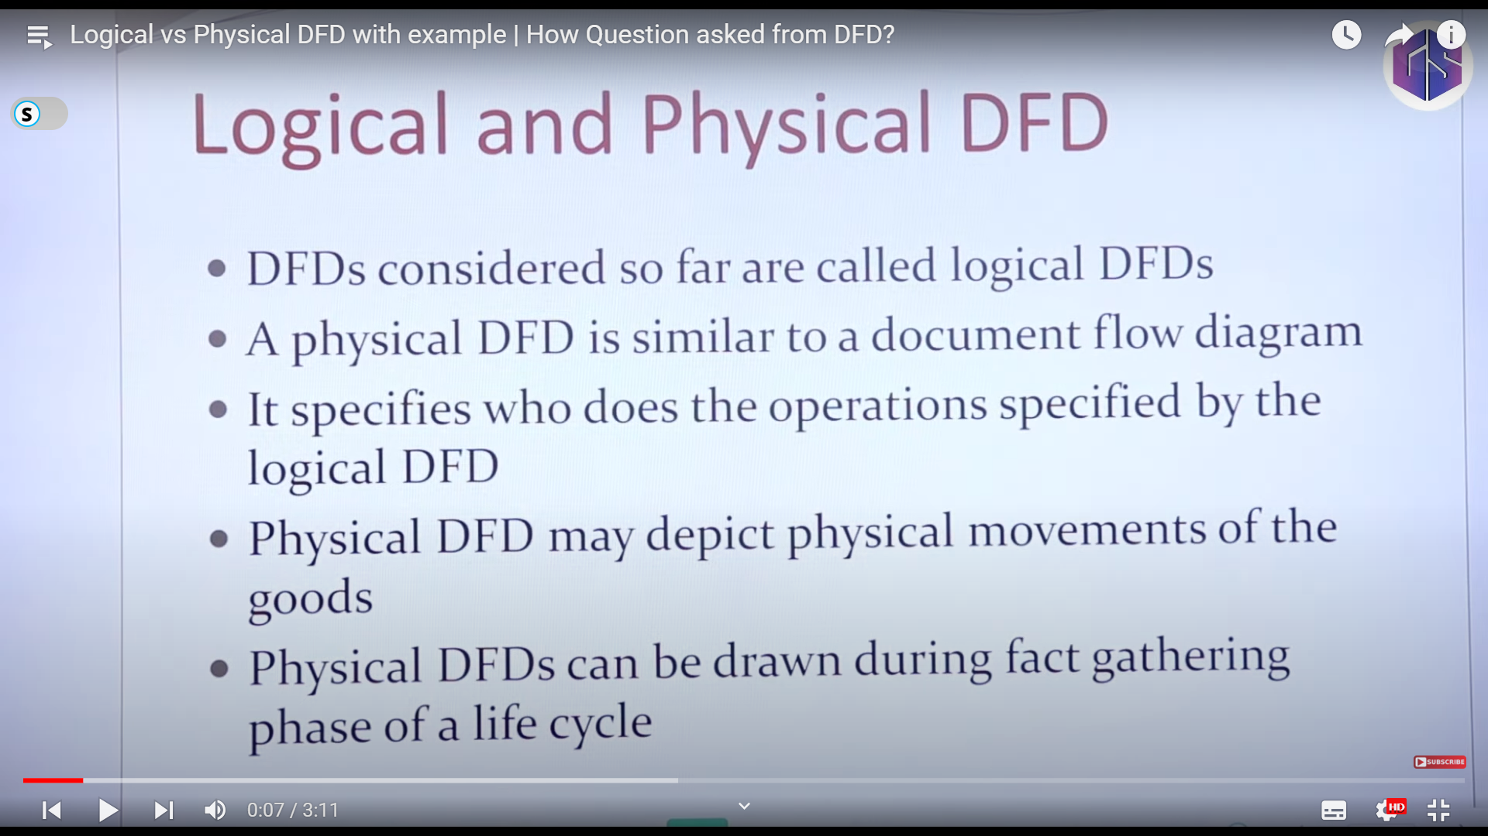

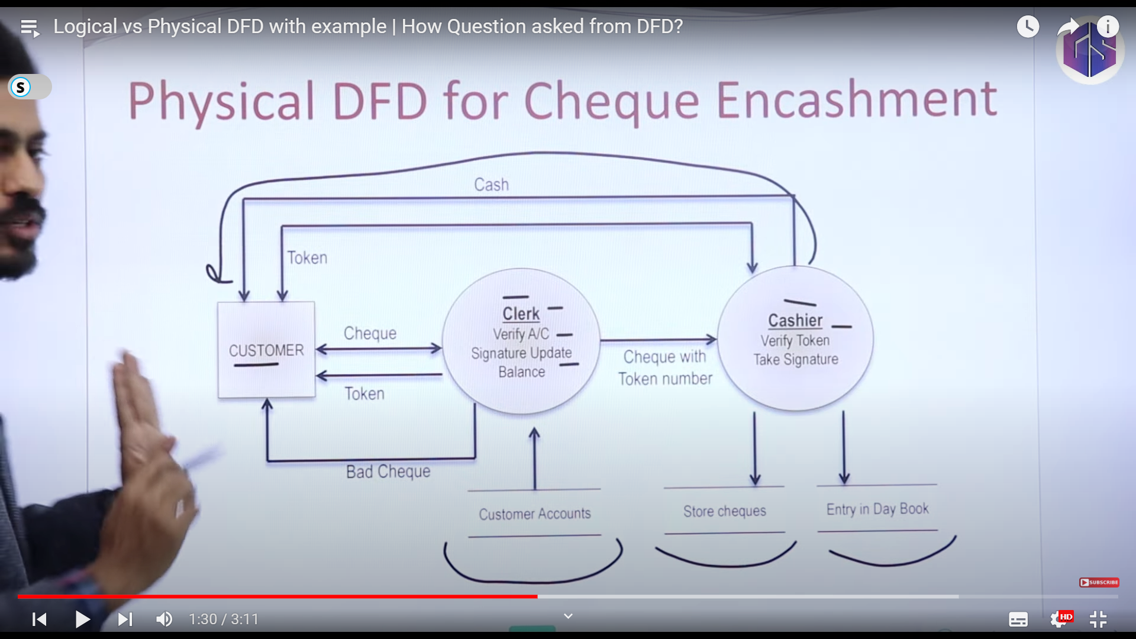

_________________________________________________________________________________________

1. Sequence diagram - <https://youtu.be/VnRQ5CNC4Fs?si=ogxZHgXOku9_t49F>

Request is given by simple line

Response is given by Dotted line

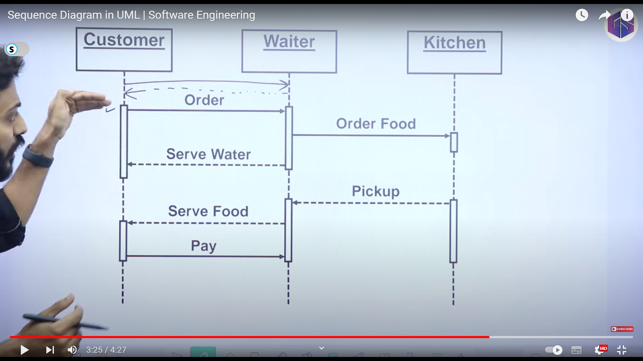

_________________________________________________________________________________________

1. Activity diagram - <https://youtu.be/LyhTDsjjjrE?si=0s04bucw6nmb1Ye7>

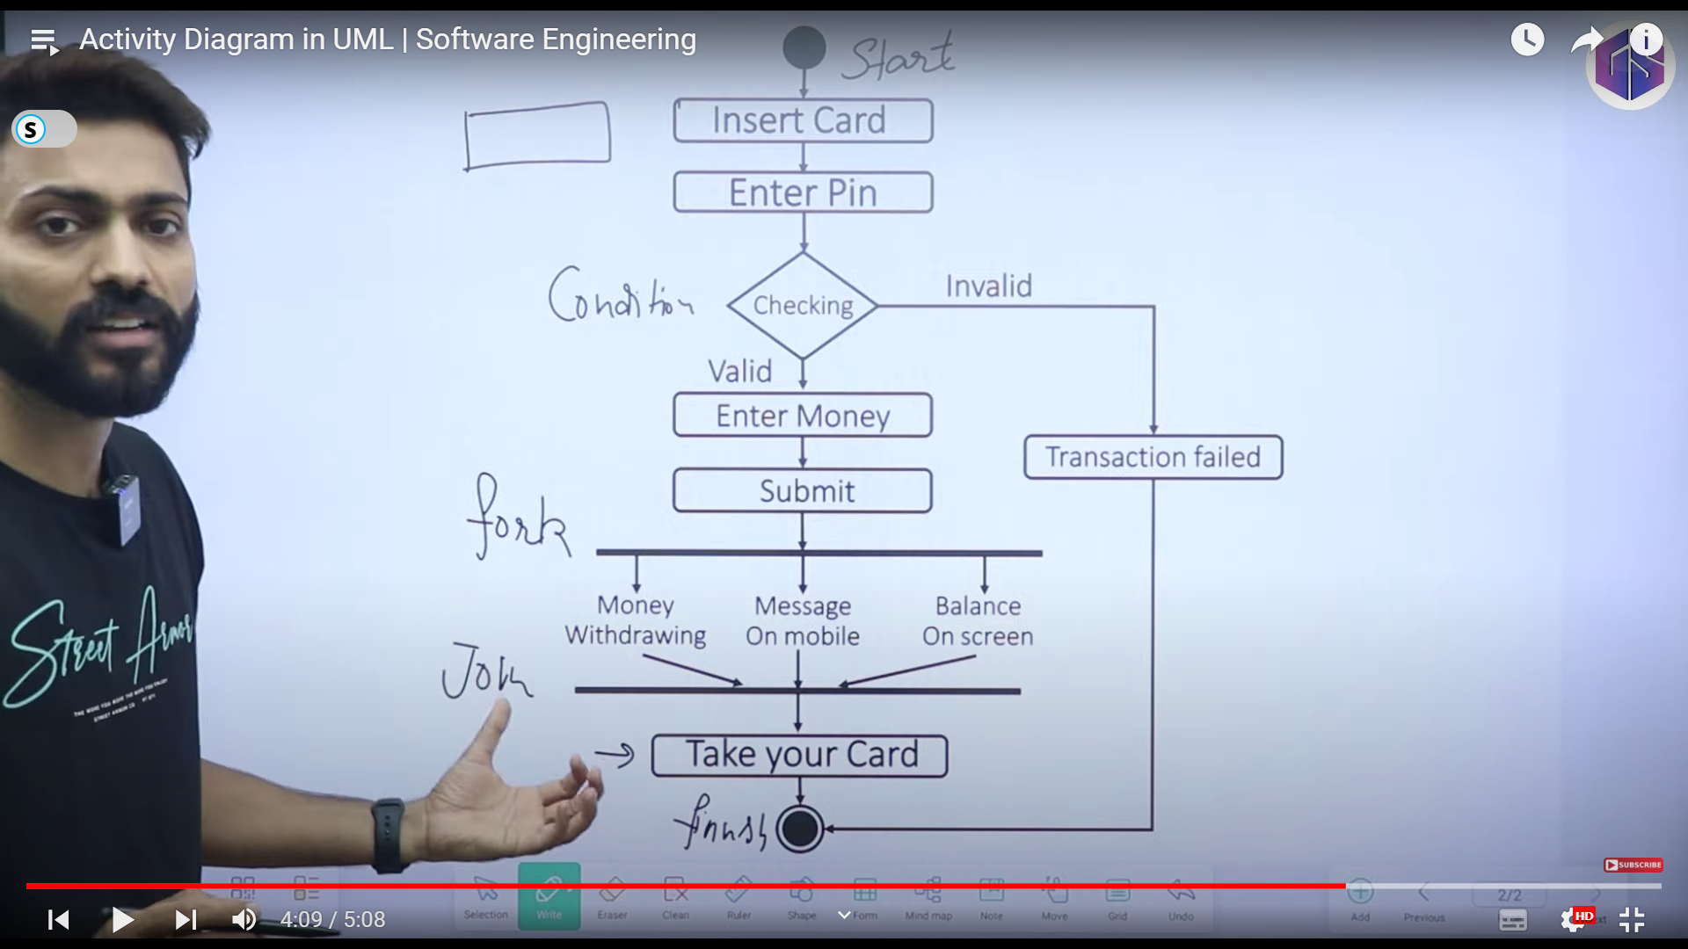

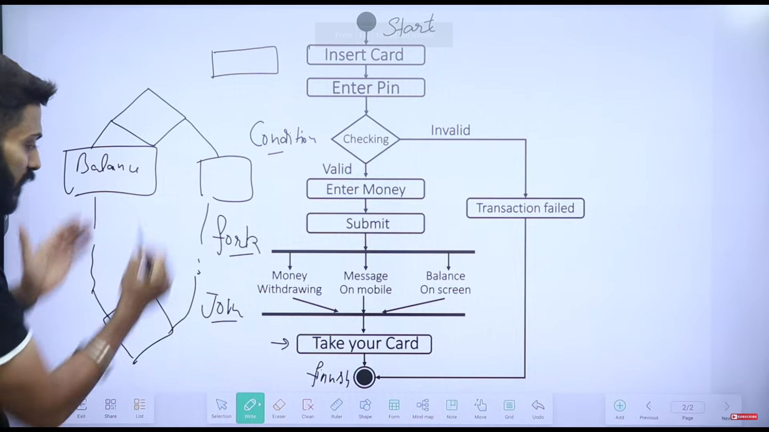

(User Requirement Specification) : https://youtu.be/a2fpi0rbr0c?si=Ecghndxm-dPNEsx9

User Requirements :

* Easy and Simple to Operate
* Quick reponse
* Effective handling operational errors
* Customer support

_________________________________________________________________________________________

Agile in Software Engineering - https://www.youtube.com/watch?v=Xs6E-MAJbfE&list=PLxCzCOWd7aiEed7SKZBnC6ypFDWYLRvB2&index=11

Agile methods break tasks into smaller iterations, or parts do not directly involve long term planning. The project scope and requirements are laid down at the beginning of the development process. Plans regarding the number of iterations, the duration and the scope of each iteration are clearly defined in advance.

Each iteration is considered as a short time "frame" in the Agile process model, which typically lasts from one to four weeks. The division of the entire project into smaller parts helps to minimize the project risk and to reduce the overall project delivery time requirements. Each iteration involves a team working through a full software development life cycle including planning, requirements analysis, design, coding, and testing before a working product is demonstrated to the client.

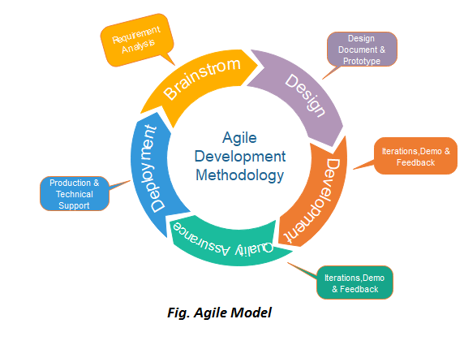

Phases of Agile Model:

Following are the phases in the Agile model are as follows:

1. Requirements gathering
2. Design the requirements
3. Construction/ iteration
4. Testing/ Quality assurance
5. Deployment
6. Feedback

Agile Testing Methods:

* Scrum
* Crystal
* Dynamic Software Development Method(DSDM)
* Feature Driven Development(FDD)
* Lean Software Development
* eXtreme Programming(XP)

_________________________________________________________________________________________

Software Requirement Specification SRS - https://www.youtube.com/watch?v=83-S5Qu6VP8&list=PLxCzCOWd7aiEed7SKZBnC6ypFDWYLRvB2&index=16

SRS Structure :

1. Introduction
   1. Purpose
   2. Intended Audience – who are to be using
   3. Scope
   4. Definations - who is administrator, principal and all
   5. References
2. Overall Description
   1. User Interfaces
   2. System Interfaces or Hardware interfaces
   3. Constraints, assumptions and dependencies
   4. User Characteristics – differenct types of users
3. System features and Requirement
   1. Functional Requirement
   2. Use Cases
   3. External Interface Requirement
   4. Logical database requirement
   5. Nonfunctional requirement
4. Deliver for Approval

_________________________________________________________________________________________

UML Diagrams - <https://youtu.be/3qKKcUZqfQk?si=0F2S17Ou1swcUKnU>

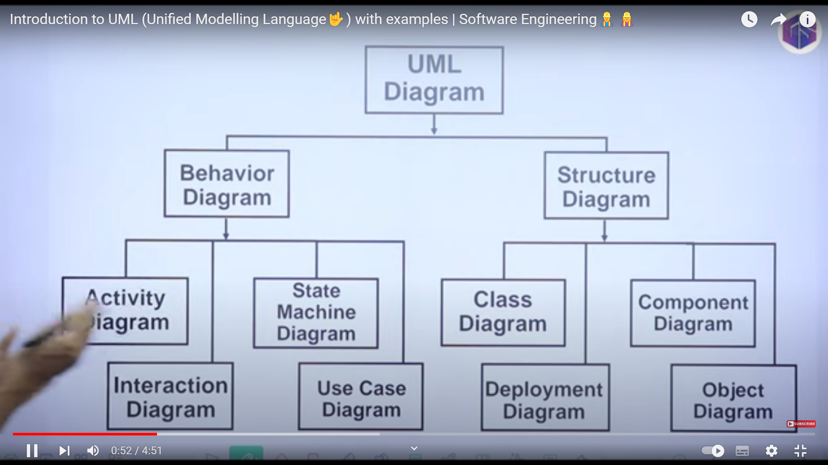

Structure Diagram : CAR : Components, Attributes, Relation

Behavoir Diagram : Dynamic



